The “Castaway”

www.ADATUM.com

CASTAWAY

The new Castaway is a British manufactured product. Originally created to help with casting, it became apparent that it has a multi-use factor.

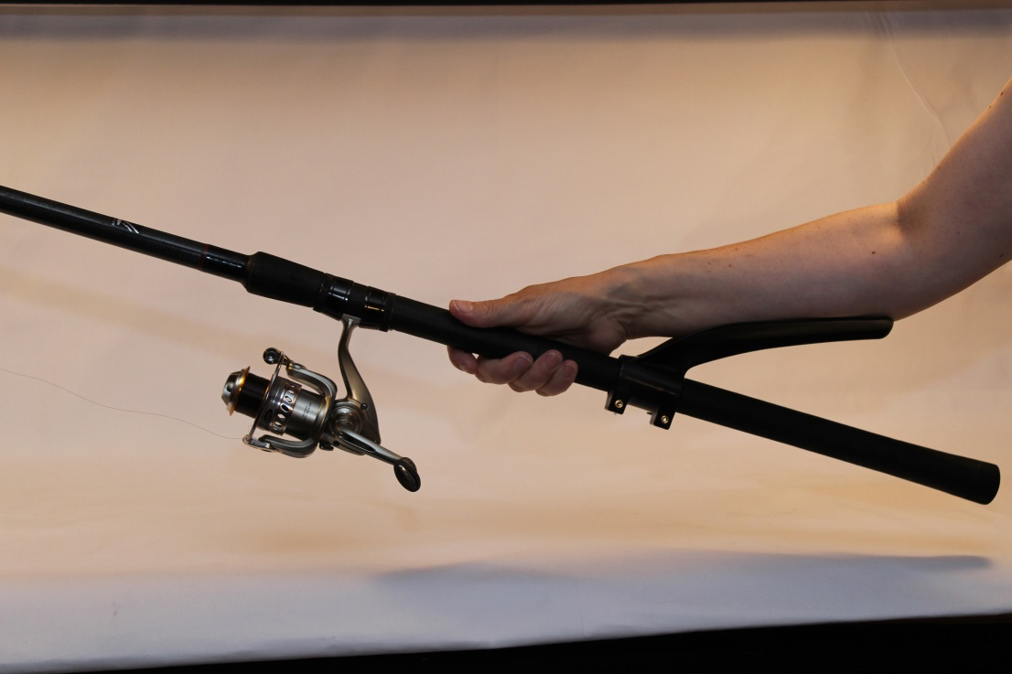
The Castaway is a fantastic piece of kit to be used as an aid for casting and landing fish… It acts as a lever that fits behind the reel or on the landing net pole, designed to take the strain from the forearm and shoulder when in the action of casting and landing. The ergonomic design means that it fits snugly to the forearm and relieves pressure and strain from the wrist, arm and shoulder and it is set to be a massive hit with the disabled and less able among us.
Helps with casting & landing

Great assistance to disabled/less abled fishermen

Takes strain from wrist and shoulder

Good for Carp Anglers

Brilliant for the “ripping” technique of fishing

Key Points

Not forgetting the Carp Anglers, who have fish on for 20 minutes and even longer. Brilliant for wreck fishermen out at sea while “ripping” for Cod and Ling; and if you have ever tried ripping, you will know how tiring that form of fishing is.

Sherwood Plastic Products Ltd
Phone: 01405 766504
Fax: 01405 752481
Email: sherwoodplastics@btconnect.com

25 Seavy Road Mosquitoangling.co.uk
Goole
East Yorkshire
DN14 6TA

www.sherwoodplastic.com

