ITM Components

News
Release

• Connectivity • KVM • Extenders • Wireless & Networking • Environment Monitoring • Data Acquisition • Industrial • Test Systems •


ITM Components

ISE Awards for Extron CrossPoint Systems
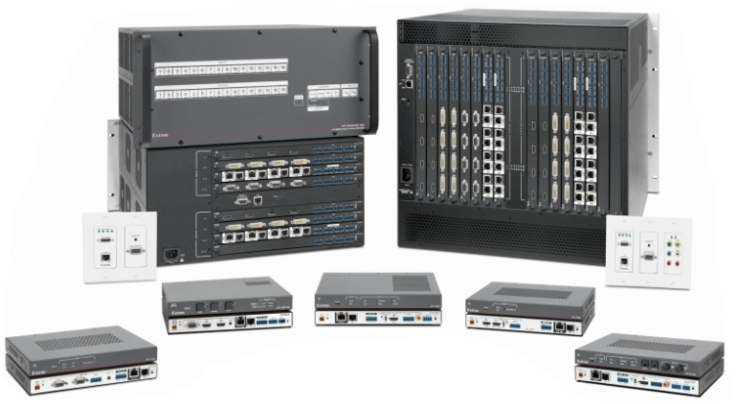
Extron XTP CrossPoint Systems
ITM Components, Ferndown, leading United Kingdom distributor for professional audio video specialist Extron Electronics, Holland, are excited to announce the recognition of the Extron CrossPoint systems achieved at the recent ISE awards ceremony. XTP CrossPoint® Systems received an EMEA Technology InAVation Award for the Most InAVative Commercial Video Processing or Distribution Product Award. Presented at Integrated Systems Europe 2012 in Amsterdam, the InAVation Awards celebrate all that is best in the Pro AV industry throughout Europe, the Middle East, Africa, and globally.
Extron XTP CrossPoint is a flexible, dependable signal switching and distribution system that provides a completely integrated solution for multiple digital and analog formats. It supports local connectivity as well as extended transmission capability for sending high resolution video, audio, RS-232, Ethernet, and power up to 330 feet (100 m) over a single CAT 5-type cable. XTP CrossPoint matrix switchers are modular and expandable from 4x4 up to 16x16 or 32x32, and can be populated with input and output boards for long distance transmission when paired with XTP transmitters and receivers. I/O boards are also available for direct HDMI, DVI, VGA, video, and audio connections to support local sources and displays.
Featuring advanced 24/7 system monitoring, hot-swappable modular components, and proven technologies such as SpeedSwitch™ Technology, EDID Minder®, and Key Minder®, XTP CrossPoint is built for continuous, trouble-free operation in the most critical applications.
For further information call ITM Components on (01202) 872771 or visit www.itm-components.co.uk.
Related Information:
ITM Components website: www.itm-components.co.uk
Press Release: Extron XTP Press Release – 27/03/2012 - Editorial Contact:ITM Components Limited - Tom Marks; Phone: 01202 872771; Email: techsales@itm-components.co.uk

