ITM Components

News
Release

• Connectivity • KVM • Extenders • Wireless & Networking • Environment Monitoring • Data Acquisition • Industrial • Test Systems •


ITM Components

NTI latest HDMI Extender with IR over Single CATx Cable
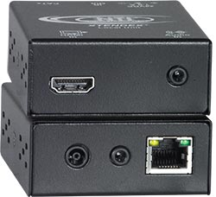
NTI ST-C6HD-IR-300 HDMI Extender
Network Technologies Incorporated, USA, global leading manufacturer of audio video equipment, are proud to announce the release of their latest HDMI Extender with IR control over a single CATx cable. ITM Components, Ferndown, are the europen distributor for NTI and this product will be available with us for immediate purchase.
NTI's XTENDEX® HDMI Extender via CAT5e/6/7, transmits digital video and audio signals up to 300 feet using one CAT5e/6/7 cable. The product features:
- Transmits HDMI signal through one CAT5e/6/7 cable.
- Available with optional support for full IR control of HDMI source from remote HDTV.
- Supports HDTV resolutions to 1080p and computer resolutions to 1920x1200 (WUXGA).
- Only one power supply is necessary to power both the local and remote units, and power can be applied at either end.
- HDCP compliant
- Support for CEC (consumer electronic control) compatible devices.
For further information call ITM Components on (01202) 872771 or visit www.itm-components.co.uk.
Related Information:
ITM Components website: www.itm-components.co.uk
Press Release: NTI ST-C6HD-IR-300 HDMI ExtenderPress Release – 27/03/2012
Editorial Contact:ITM Components Limited
Tom Marks; Phone: 01202 872771; Email: techsales@itm-components.co.uk

